SPECIFICATIONS SECTION

FLOOD CONTROL VENT GATES

PART 1 GENERAL

  - SECTION INCLUDES
    - Flood Control Ventilation Gates

  - RELATED SECTIONS

    - N/A.
  - REFERENCES

    - ASTM C 39 - Standard Test Method for Compressive Strength of Cylindrical Concrete Specimens.

    - ASTM F593 – Standard Specification for Stainless Steel Bolts, Hex Cap Screws and Studs

    - AWS - American Welding Society.

    - FEMA - Federal Emergency Management Agency.

    - The Aluminum Association - Aluminum Design Manual, 2015
    - ASCE 7-2010 – Minimum Design Loads for Buildings and Other Structures, 2010

  - DEFINITIONS

    - Mitigation Height: The height of flood waters based on the local FEMA five-hundred
(500) year flood plain plus one (1) inch.

  - SUBMITTALS

    - Submit under provisions of Section .
    - Product Data: Manufacturer's data sheets on each product to be used, including:
      - Preparation instructions and recommendations.
      - Storage and handling requirements and recommendations.
      - Installation methods.

    - Shop Drawings: Submit plan, section, elevation and perspective drawings as necessary to depict proper placement, installation and operation methods for each gate to be installed.

  - QUALITY ASSURANCE

    - Manufacturer Qualifications: All primary products specified in this section will be supplied by a single manufacturer with a minimum of 5 years' experience in installing and servicing passive flood solutions.

    - Installer Qualifications: All Work listed in this section is to be installed under direct supervision of a Floodbreak representative. Floodbreak representative must be on- site during vent gate installation.

    - Mock-Up: Provide a mock-up for evaluation of surface preparation techniques and application workmanship.
      - Finish areas designated by Architect.
      - Do not proceed with remaining work until workmanship, color, and sheen are approved by Architect.
      - Refinish mock-up area as required to produce acceptable work.

  - DELIVERY, STORAGE, AND HANDLING
    - Store products in manufacturer's unopened packaging until ready for installation.

    - Store and dispose of hazardous materials, and materials contaminated by hazardous materials, in accordance with requirements of local authorities having jurisdiction.

  - PROJECT CONDITIONS

    - Maintain environmental conditions (temperature, humidity, and ventilation) within limits recommended by manufacturer for optimum results. Do not install products under environmental conditions outside manufacturer's absolute limits.

  - WARRANTY

    - At project closeout, provide to Owner or Owners Representative an executed copy of the manufacturer's standard limited warranty against manufacturing defect, outlining its terms, conditions, and exclusions from coverage.

PART 2 PRODUCTS
  - MANUFACTURERS

    - Acceptable Manufacturer: FloodBreak Automatic Floodgates, which is located at: 2800 Post Oak Blvd. Suite 5850 ; Houston, TX 77056; Tel: 713-980-6610; Fax: 713- 629-9936; Email: info@floodbreak.com; Web: www.floodbreak.com

    - Substitutions: Substitutions are allowed so long as all other requirements of the specification are met by the substitute bidder.

    - Requests for substitutions will be considered in accordance with provisions of Section 01600.

  - APPLICATIONS/SCOPE

    - Provide a means of passively protecting human and property assets subject to damage during a flood caused by external forces. Passive shall mean that the vent gate functions without human intervention or power to make the vent gate deploy.

  - DESIGN REQUIREMENTS

    - Design vent gate system height based on the Mitigation Height at the location of the gate as determined by the Federal Emergency Management Agency (FEMA) or equivalent entity.

    - Design the vent gate with minimal airflow reduction in the “open” position

    - Design the vent gate to hinder the passage of floodwater and resist hydrostatic pressures while in its operating or "closed" position, and only” close” to the flood height.

    - Per client request additional flooding loads could be considered, such as debris loads or greater hydrodynamic pressures.

    - Design the gate to exclude the use of any electric pumps or other ancillary powered support equipment for operation in passive mode.

  - COMPONENT

    - GATES: 1/8" (dry side), ¼” (wet side) and 3/8” (wet side) aluminum smooth plate – Aluminum Grade 5052. Thickness to be determined by Engineer of Record based on water weight.

Minimum Yield (Fy) = 25.8 ksi.

Flat Bars, Structural Angles, Hinges - Aluminum Grade 6061-T6 - Minimum Yield (Fy) = 35 ksi.

    - Gaskets: 3/16-inch (4.8mm) EPDM rubber.
    - Hardware:
      - Hinge Pins:

Material: 1/2-inch (13mm) diameter ASTM F593 Grade 304 Stainless Steel.

b. Minimum Yield (Fy): 50 ksi.

      - Bolts:
        - Material: Countersunk ASTM F593 Grade 304 Stainless Steel. Bolt diameter as noted on the contract drawings.
        - Minimum Yield (Fy): 50 ksi.

      - Welding Wire: Aluminum Wire - ER 4043 AWS A5.10 3/32
    - Gasket Flanges:
      - Material: 1/4 inch (6mm) 6061-T6 aluminum.
      - Minimum Yield (Fy): 35 ksi.
    - Structural Angles:
      - Material: 1/4 inch (6mm) structural 2 inch by 2 inch (51mm x 51mm) angles - 6061-T6 aluminum.
      - Minimum Yield (Fy): 35 ksi

  - FABRICATION
    - General Requirements:
      - Fabricate all components and elements following the standards, tolerances and guidelines noted in the contract drawings.
      - All welding to be performed by a certified welder in accordance with AWS standards and guidelines.
      - Tighten all bolts to torque specifications determined by the manufacturer and Engineer of record.
    - Vent Gate:
      - At panel joints, stitch weld every 5 inches (127mm) on center with a 3/16-inch fillet weld 3 inches (76mm) long. Contractor shall verify with Engineer of Record these weld requirements prior to start fabrication
      - At panel splices, place splice flanges within 12 inches (305mm) of adjacent retention arms.

  - DRAWING

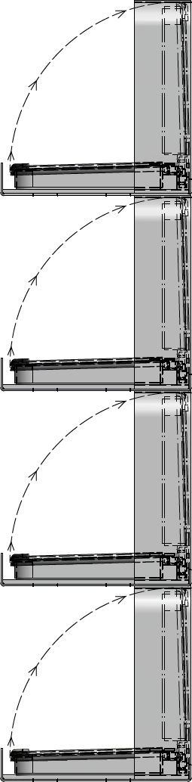
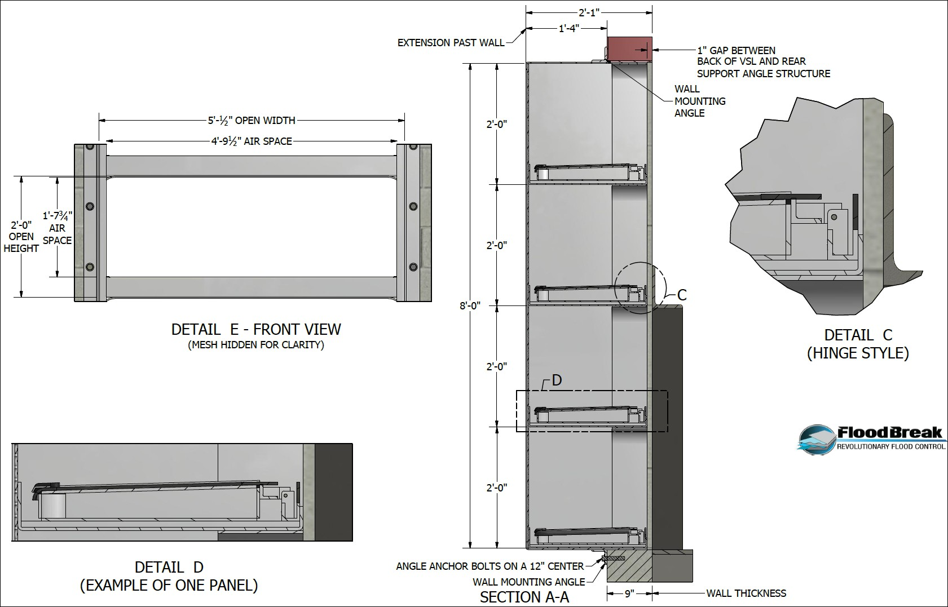

FLOOD CONTROL VENTILATION GATE

PART 3 EXECUTION

  - PREPARATION

    - Clean surfaces thoroughly prior to installation.
    - Prepare surfaces using the methods recommended by the manufacturer for achieving the best result under the project conditions.

  - INSTALLATION
    - Install in accordance with manufacturer's instructions.

  - PROTECTION
    - Protect installed products until completion of project.

    - Touch-up, repair or replace damaged products before Substantial Completion.

END OF SECTION

